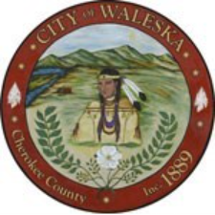
CITY OF WALESKA
Regular Meeting of the Mayor and Council
8891 Fincher Rd.
Waleska, Ga 30183
September 21, 2026
6:30 p.m.

Item 1: Call to Order
Item 2: Invocation / Pledge of Allegiance
Item 3: Consideration to Approve the Regular Meeting Minutes September 8, 2026
Item 4: Five Minute Public Input
Item 5: Angel Quintana – Discussion Regarding Zoning of Property on Reinhardt College Parkway
Item 6: Yard of the Month
Item 7: Water System Report
Item 8: City Clerk’s Report
Item 9: City Attorney’s Report
Item 10: Mayor’s Report
Item 11: Council Remarks
Item 12: Adjournment of Regular Council Meeting

